**AY2018 Semester 2**

|  |  |  |  |
| --- | --- | --- | --- |
| Name |  | | |
| Student ID |  | | |
| Assessment Venue |  | Seat Number |  |

**E356 ESE**



E356: PHARMACEUTICAL AND BIO-CHEM SUPPLY CHAIN

**AY2018 Semester 2 End-Semester Examination (ESE)**

|  |  |  |
| --- | --- | --- |
| ***This segment is to be used by staff grader(s) only.*** | | |
| **Question Number** | **Marks Awarded** | **Max Marks** |
| **1** |  | **11** |
| **2** |  | **8** |
| **3** |  | **26** |
| **4** |  | **7** |
| **5** |  | **19** |
| **6** |  | **21** |
| **7** |  | **8** |
|  |  |  |
|  |  |  |
|  |  |  |
|  |  |  |
|  |  |  |
|  |  |  |
|  |  |  |
|  |  |  |
|  |  |  |
|  |  |  |
|  |  |  |
|  |  |  |
| **Total** |  | **100** |

|  |  |  |  |
| --- | --- | --- | --- |
| **Instructions to student:** | | | |
| 1) | Do not turn over this question paper until you are instructed to do so by the invigilator. | | |
| 2) | Write your name, student ID, assessment venue and seat number in the table provided at the top of each page. | | |
| 3) | For this question paper, there are **19** pages (including this cover page). | | |
| 4) | For this assessment, you are allowed to:   * Refer to materials stored in your laptop. * Have only one set of hardcopy notes in bound form, and no larger than A4 size * Have a blank piece of paper for rough working purpose. (Note that the sheet of rough working paper will not be accepted for submission at the end of the assessment.) | | |
| 5) | For this assessment, you are **NOT** allowed to:   * Refer to textbooks and written materials or hardcopy notes in unbound form. * Share any material, such as calculators, with another student. * Communicate with any person other than the invigilator. * Use any communication devices such as handphone or smart watches while at the assessment venue. | | |
| 6) | All rules and regulations pertaining to summative  assessments and academic integrity stated in the Student Handbook shall also apply. | | |
|  | ***This segment is to be used by the invigilator only and for ‘online’ and ‘online and paper’ mode assessments only.*** | | |
|  | Please tick the box below if the student has done part of the assessment online: | Invigilator’s Name: | Invigilator’s Signature: |
|  | Partially done online |  |  |

Page 1 of 19

**QUESTION 1** [11 Marks]

Jason just joined a retail pharmacy in Singapore. He is mainly in charge of store replenishment and helping out his colleagues in the store.

1. Pharmaceutical products usually have a short shelf life. As such, what is the important information to be printed on the drug package that Jason needs to check regularly?

[1 mark]

The manufactured date and expiry dates.

1. The retail pharmacy sells items like bandage and thermometer. Are these items classified as pharmaceutical product? Give **One** (1) reason to justify your answer.

[2 marks]

No. Pharmaceutical sare substances used in the diagnosis, treatment, or prevention of disease, however, bandages and thermometers are not substances but are medical devices which refers to any instrument, apparatus, implement, machine or appliance.

1. A customer visited the pharmacy to purchase sleeping pills with a prescription from the doctor. What is the type of this medicine in terms of the access to the public?

[1 mark]

Pharmacy Only Medicines since the case is describing a therapeutic product that can be obtained from a pharmacist at a retail pharmacy.

1. What are the **TWO** (2) main sales channels for the pharmaceutical products to consumers?

[2 marks]

Retail pharmacy and Internet pharmacy.

1. One day, a customer approached Jason and passed him a medicine package as shown in Figure 1.1, He asked how to check if the medicine is fake or not by observing this package. What kind of anti-counterfeit feature can Jason advice his customer to check? Suggest **TWO** (2) disadvantages of this feature from the end customers’ perspective.

[3 marks]

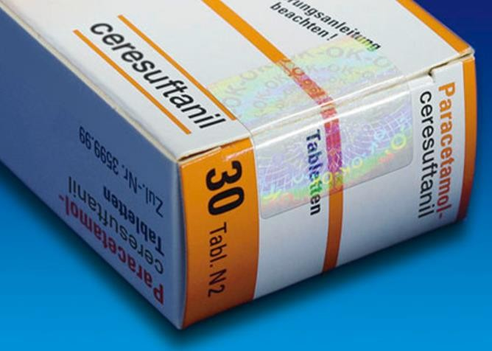

Figure 1.1

As shown in Figure 1.1, there is a sticker with a hologram which is an anti-counterfeit feature can Jason advice his customer to check. Jason should explain that the sticker will reveal the holographic image when tilted in light. Furthermore, the image revealed is customized and unique to the brand owners to allow easy identification of authenticity.

Disadvantages are it can be easily mimicked ot just close enough to confuse consumer. Another is mentioned in this question whereby Jason explains the feature to the customer; this means it requires user education and is not always widely understood.

1. Jason recently read an article and knew that the manufacturing of a pharmaceutical product is separated into Primary and Secondary Manufacturing phase. Why are more and more companies choosing to separate both phases geographically? **Explain**.

[2 marks]

The secondary manufacturing locations are often geographically separated from the primary manufacturing

locations. This is frequently because of the outcome of tax and transfer price optimization within the enterprise. This also results in often many more secondary manufacturing sites than primary ones, serving local or regional markets.

**QUESTION 2** [8 Marks]

1. The following document describes WARMMARK (in Figure 2.1a) and COLDMARK (in Figure 2.1b) indicators which can be used to ascertain whether a pharmaceutical product has been exposed to ascending or freezing temperatures during transit. Regina wanted to transport 10 cartons of flu vaccines from airport to a few hospitals in Singapore mainly in the west side.

|  |
| --- |
|  |
| Figure 2.1a |

|  |
| --- |
|  |
| Figure 2.1b |

Suggest the part number of WARMMARK tags and COLDMARK indicators respectively that she should buy if the optimum temperature of vaccines is between 2℃ to 8℃? Give **ONE** (1) reason for each.

[4 marks]

WARMMARK tags – Part number 505/WM2. This is because the allowed temperature range is 2℃ to 8℃ and in summary from Figure 2.1a, Part number 505/WM2 will show on display if there has been an exposure above 8℃.

COLDMARK indicators – Part number 520. This is because the allowed temperature range is 2℃ to 8℃ and in summary from Figure 2.1b, Part number 505/WM2 will show on display if there has been an exposure below 2℃.

1. Can the indicators be used to record the temperature of the whole journey if the vaccines were to be transported from Singapore Changi airport to Jurong Hospital?

Given **ONE (1)** reason. [2 marks]

No. Although indicators monitor whether a product has been exposed to temperatures above a pre-determined threshold as a red dye, this only gives a quick indication on temperature excursions but do not give details of when it happened.

1. What can you use to monitor the temperature if the vaccines were to be sent from Singapore Changi airport to Vietnam-Ho Chi Minh airport and from the airport to warehouses?

Suggest **ONE (1)** method whereby you can monitor the real-time temperature.

[2 marks]

One method is to use a temperature data logger that continuously sends data to a cloud platform. A temperature data logger, also known as the temperature monitor is an instrument that autonomously records the temperature over time. It automatically collects, monitors, and stores the information. Additionally by enabling the feature of uploading this information to a cloud, the data is made accessible via the cloud the moment it’s recorded achieving the monitoring of real-time temperature.

**QUESTION 3** [26 Marks]

Kirby is the Material Manager in Cheng Lim Hospital. He is in charge of medical supply as well as the bio-waste management. The hospital outsources the logistics of DG to a 3PL company, Zufi Logistics.

1. In the aesthetic department in hospital, **Liquid Nitrogen** is used in cryotherapy or cryosurgery to remove abnormal skin growths. Given that Liquid Nitrogen has the following warning label:



State the Dangerous Goods (DG) Class and the description. [2 marks]

Class 2.2. Description: Non-flammable non-toxic gas.

1. Zufi Logistics provides storage services to the hospital. How does HSA (Health Science authority) ensure that Zufi Logistics adheres to the guidelines under GDP?

[2 marks]

HSA's auditors will conduct audits on the company in accordance to the GDP- HSA (Ref. No.: GUIDE-MQA-013-005)

1. Kirby orders 20 drums of sodium Hydroxide (a corrosive liquid) and plans to store in a room, which also stores two tanks of liquid nitrogen. Can he do this? Justify your answer.

[2 marks]

Yes, he can do this. In the Dangerous Goods Segregation Table, the cell whereby Class 8 Corrosive Liquids (sodium Hydroxide) and class 2.2 Non-toxic Non-flammable Gases (liquid nitrogen) meet indicates that no restrictions apply.

1. Regina, the operations manager in Zufi Logistics, is particular about the
   1. Temperature and facilities
   2. Stock handling and control

Based on GDP, suggest **THREE (3)** measures each in i. and ii that she has to take note.

[6 marks]

(i) Temperature / Humidity control – Use of cold room with backup generator, proper temperature and humidity monitoring.

Controlled exposure to UV rays – Storage away from sunlight

Clean environment - Use of HEPA (High Efficiency Particulate Air) filter which can remove at least 99.97% of airborne particles 0.3 micrometers (µm) in diameter.

(ii) Receiving and Handling - Written Procedure; Distribution records and duration of storage

to be kept.

Stock Rotation and Control - EEFO (Earliest-Expiry-First-Out)/ FIFO.

Deliveries to Customer - Protection of the quality of materials during transportation to customers

1. Label A and B shown in Table 3.1 are for flammable materials stored in DG warehouse in Zufi Logistics. Identify the difference between the two labels by filling up the table below:

[6 marks]

# Table 3.1

|  |  |  |
| --- | --- | --- |
|  | Related image  **Label A** | Image result for UNRTDG flammable symbol  **Label B** |
| Type of Classification | Class 2 | Class 3 |
| Intention of classification | Flammable Liquid | Flammable Gas |
| Example of location for label | GHS label on consumer product packages, in this case, it can be on the drum packaging. | GHS label on consumer product packages, in this case it can be on the cylinder packaging. |

1. Currently, the bio-waste storage area is at a temporary location in the hospital. State **THREE (3)** precautions Kirby needs to take to ensure smooth operations of the temporary bio-waste storage.

[3 marks]

Waste Segregation • Separate general waste from hazardous waste and pack into correct coloured waste bags and containers.

Collection of waste

• Regular collection

• Specific routes to be followed to reduce contact

• Loading and unloading should be easy

• No sharp edges that can tear the bags

• Equipment should be easy to clean later

1. Under WHO healthcare waste classification, which category of healthcare waste requires special attention?

[2 marks]

special pharmaceutical waste • E.g. antibiotics, vaccines, other immunological products, and controlled drugs such as cocaine. • needs special disposal by medical waste incineration.

1. Occasionally the following situations occur:
2. users trigger emergency orders for certain medical product
3. users pick from the inventory without notifying Kirby’s department

In inventory point of view, how will the users’ action affect the company? State

**THREE (3)** implications. [3 marks]

The user picking without notifying Kirby’s department could lead to unattended or unexpected stockouts and one implication is that the necessary inventory might not arrive until at least a day later, and in some cases, it can take even longer. Consequences are especially severe for the patients and the staff. If the staff do not have the items within the on-site inventory needed to treat and help a patient and has to make an emergency order, the delay implicates a possible loss of life and unethical extension of suffering.

Furthermore, this might also lead to a constant lack of inventory especially if the supplier cannot provide enough to replenish the previously diminished inventory and at the same time, ensure they sustain an optimal level of inventory for the following period.

Consequently, another implication is that the purchase of a single product via emergency orders because of stock out often requires an excessive freight and transportation cost that could have been lessened if the order was merged or shipped together with a previous delivery; only if Kirby’s department had been notified prior..

**QUESTION 4** [7 Marks]

A diagnostic type of clinical trial study with the primary objective of determining the accuracy of diagnosing Dengue Fever using a trial kit was concluded recently. Dengue Fever is infectious and severe cases may result in deaths.

1. What type of clinical studies does clinical trials fall in? What are the possible items that you will pack in a trial kit required for conducting clinical trials?

[4 marks]

. Diagnostic trials.

• Investigational Product (IP) / Investigational Medicinal

Product (IMP) / Trial Product – A trial product / drug that has

not been approved for general use but is under investigation

in clinical trials.

• Placebo - An inactive drug / product that has no treatment

value, often used as a reference for comparison to assess

the IPs effectiveness.

• Auxiliary Supplies other than trial product, e.g. all equipment

such as needles, other medical devices and dummy

packages, etc.

1. Identify the clinical trial phase after the drugs have been sold in the market.

[1 mark]

In Phase IV trials, post marketing studies delineate

additional information including the drug's risks, side

effects, benefits, and optimal use.

1. In an overseas clinical trial, investigational products are packed for each participant before being sent to the local clinic. Based on the principle of GMP, how should you repackage the trial product if required? Suggest **TWO (2)** ways.

[2 marks]

Line clearance: Pack one type of IP at a time. • In-process control checks: IP re-packaging should be performed and witnessed by delegated and trained unblinded study staff. • Label re-conciliation : No. of IP labels issued = No. of IP labels used + destroyed + remaining; • Documentation: The IP re-packaging process should be documented and signed off by the unblinded study staff

**QUESTION 5** [19 Marks]

1. Health products are regulated by Health Science Authority (HSA). List **THREE** (3) Acts that pertain to Health Products under HSA. [3 marks]

Health Products Act (HPA)

Poisons Act

Misuse of Drugs Act

1. As regulated under HSA, identify the **TWO** (2) instances where the Form A Poisons License is necessary. [2 marks]

import, possess for sale, sell or offer for sale any poisons. Import / Export Therapeutic Products containing psychotropic substances.

1. The National Environment Agency (NEA) regulates Hazardous Substances (HS) in Singapore. State the difference between the HS License and HS Permit.

[2 marks]

There are different licenses and permits to legally carry out different operations of the supply chain for different types products. Licenses are for Importing, Exporting, Selling while Permits are for Storage, Buying.

1. *Formaldehyde* is classified as a “Hazardous Substance” (HS) under NEA. Table

5.1 below shows an extraction from *Table 1: List of Controlled Hazardous Substances* that is published by NEA. If you wish to sell a substance containing **10% of Formaldehyde**, do you need to apply for the HS License? **Justify** your answer.

[2 marks]

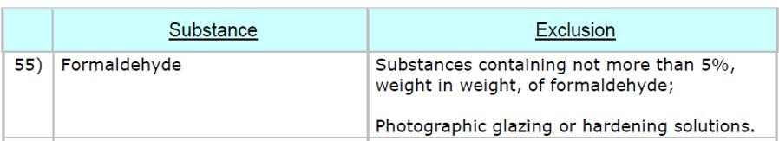Table 5.1

Yes, they need to apply for the HS License. Substances containing not more than 5%, weight are excluded, however, 10% is above this exclusion.

1. To transport *Formaldehyde*, the Transport Emergency Response Plan (TERP) which includes the Safety Data Sheet (SDS) has to be submitted. What is the purpose of the SDS AND why is it important to include the SDS in the TERP?

[4 marks]

SDS is a document that provides comprehensive information on the chemical, pharmaceutical or biochemical product. SDS is essential in the TERP since SDS information includes instructions for the safe use and potential hazards associated with a particular material or product, along with spill-handling procedures. The handling procedures is used to carry out an immediate response such as immediate first aid and safety measures.

1. Based on the table below extracted from NEA’s Table 2, determine the type of licenses / permits / approval that are necessary before a shipment of *2 Metric Ton of Formic acid* can be shipped locally. (2 Metric Ton is equivalent to 2000kg)

[4 Marks] NEA’s Table 2 - Schedule of Environmental Protection and Management (HS) Regulations



HTDP for driver (SCDF)

TERP approval (SCDF)

HS Transport Approval (NEA)

HS list in slide 10, need to install HTVTS

1. The Singapore Police Force regulates Explosive Precursors in Singapore. Explain why Explosive Precursors are regulated.

[2 marks]

An explosives precursor is a chemical substance which can be made into an explosive with relative ease e.g. by mixing or blending with other substances, or by simple chemical processing. The list of 15 explosive precursors were assessed based on their chemical properties and their widespread use in Singapore and also on their potential for use by terrorist in improvised explosive devices.

**QUESTION 6** [21 Marks]

Jay, who works in Maz Laboratories, is going to ship an infectious substance, 40mL of African swine fever virus (cultures only) from Singapore to Indonesia by air. Jay has decided to use 10kg dry ice as a refrigerant for the shipment as the virus needs to be kept at -300C or below.

1. Fill in the 4 blanks below

[4 marks]

He needs to refer to the IATA Dangerous Good Regulation (DGR) for the guidelines on shipping infectious substances by air. Jay understands that there might be restrictions from Singapore and/or Indonesia, and he has to refer to Section 2 to check on these restrictions.

He has selected Indonesia’s national carrier, Garuda Airlines, for the shipment; to confirm if Garuda Airlines is willing to accept the shipment, Jay can refer to Section of the IATA DGR.

Packing infectious substances for air shipment can be challenging, Jay should refer to Section 5 to find out how to meet the requirements to pack the virus.

After Jay has done the proper marking and labelling on the package, the next step he needs to do is Complete Dangerous Good Declaration, and then submit to carrier together with the package.

1. Explain why IATA regulates shipments of infectious substances.

[2 marks]

Infectious substances are substances which are known or are reasonably expected to contain pathogens. Pathogens are defined as micro-organisms (including bacteria, viruses, rickettsiae, parasites, fungi) and other agents which can cause disease in humans or animals. During disease outbreaks, countries need to have the capacity and expertise to ensure the safe transport of infectious substances.

1. Jay found out that the above African swine fever virus (cultures only) is classified as a Category A, UN2900 infectious substance. Identify the difference between UN2814 and UN 2900 which are both classified as infectious substances.

[2 marks]

Infectious substances meeting these criteria which cause disease in humans or both in humans and animals shall be assigned to United Nations number UN 2814. Infectious substances which cause disease only in animals shall be assigned to UN 2900.

1. For the packaging of Category A infectious substances in a shipping system, state **THREE** (3) tests that the packaging must go through before it can be UN- certified.

[3 marks]

Pressure tested at 95 kPa

Drop tested from 9 m

Puncture tested at 7 kg

Stacking tested

1. The marking below is sometimes found in infectious substances packages. Identify the marking shown below, and explain its purpose.

[2 marks]



“UN-specification” (that’s UN as in United Nations). This means that the packaging has been tested to international standards of integrity, such as drop and pressure testing.

1. According to IATA, what is the packing group for the African swine fever virus (cultures only) and dry ice, respectively? Justify your answer.

[3 marks]

Dry Ice is listed under Packing Group III as there is a possibility only for minor damage. Dry Ice (carbon dioxide) when offered for transportation, that could or will involve air, must be in packaging designed and constructed to permit the release of carbon dioxide gas and to prevent a build up of pressure that could cause rupture of the package.

1. Below is a diagram showing the package for the above shipment to Indonesia. Identify **FIVE** (5) mistakes. [5 marks)

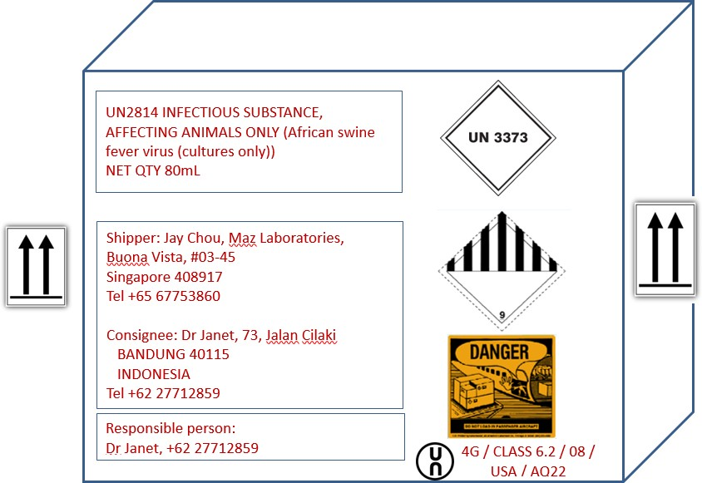

**QUESTION 7** [8 Marks]

Tina is working in a pharmaceutical distribution centre in SEMD Pte Ltd, which has possessed Importer’s and Wholesaler’s Licence to import and supply medical device in Singapore.

1. Tina’s 1st task is to import a Class C medical device from Malaysia, this device has been approved by National Pharmaceutical Regulatory Agency (NPRA) - the Drug Control Authority of Malaysia. How long does it take HSA to process the product registration if she submits application today? Justify your answer.

[3 marks]

1. Tina’s 2nd task is to import a Class A medical device. How much does she need to pay for the product registration? What document does she need to submit to HSA?

[3 marks]

1. If SEMD would like to export medical device, what is the other licence that the company needs to apply? Justify your answer.

[2 marks]

# END OF PAPER